**ECONOMIC IMPACT OF COVID19 PANDEMIC ON THE NIGERIAN STOCK MARKET:**

A Data Analytics project by Joseph Ozaveshe Michael

**Abstract**

This paper attempts to explore the direct effects and spill-overs of COVID19 on the Nigerian stock markets. We empirically analyze daily return data from stock markets in Nigeria using the ARIMA model. Our empirical results show that

1. COVID-19 has a negative but short-term impact on the stock price.
2. The findings contribute to the research on economic impact of the pandemic by providing empirical evidence that COVID-19 has spill-over effects on the Nigerian stock markets.
3. The results also provide a basis for assessing trends in international stock markets when the situation is total alleviated worldwide.

**Introduction:**

An unanticipated disease called coronavirus disease 2019 (COVID-19) has spread worldwide since the end of 2019. In December 2019, Wuhan, a central city in China, reported the first COVID-19 case. On 3 January 2020, the Wuhan Health Committee reported 44 cases of viral pneumonia of unknown cause. Due to mass migration during the Chinese New Year and Wuhan’s geographic location as an important transportation hub in China, the disease has spread silently to other provinces in China since early January 2020. On 19 January, the first three confirmed cases outside Wuhan were reported, one in Guangdong and two in Beijing. Since 10 am on 23 January, bus, metro, ferry and long-distance passenger transportation in Wuhan had been suspended. As a further precaution, all outbound trains and flights were stopped. The Chinese government continues to adopt various public health policies, such as travel restrictions, curfews and school closures to prevent the spread of the epidemic. On 30 January 2020, the World Health Organisation (WHO) issued its first global alert regarding COVID-19 (WHO [2020a](https://www.tandfonline.com/doi/full/10.1080/20954816.2020.1757570?scroll=top&needAccess=true&)). As the number of confirmed cases soared throughout the world, the WHO announced it as a pandemic on 11 March 2020 (WHO [2020b](https://www.tandfonline.com/doi/full/10.1080/20954816.2020.1757570?scroll=top&needAccess=true&)). So far, the countries with the largest number of confirmed cases in the world include the People’s Republic of China, Italy, South Korea, France, Spain, Germany, Japan and the United States of America. The outbreak center has been gradually shifted from China to Europe and the USA. When the China A-share market reopened on 3 February, the Shanghai Securities Composite Index declined by nearly 8% in response.

The unfortunate situation created by COVID-19 gives us a unique opportunity to gauge the impact of an unexpected and dreaded disease on the economy of affected nations. The COVID-19 virus first broke out in China and exerted a direct influence on China’s stock market. Fluctuations in China’s stock market may have spill-over effects on others due to the breadth and depth of interdependence among contemporary economies. In China, the spread of the disease is gradually being curtailed, but it continues to spread in other countries, some of which might adversely influence back on China’s stock market.

.

Our paper documents the latest impact of COVID-19 on stock markets of the Nigerian Stock Exchange. And, it provides a reference for assessing trends in local and international stock markets after the pandemic subsides.

**Data and Methodology**

To examine the impact of COVID-19, the Nigerian All-Shares Index was chosen to represent the entire stock price listed on the Nigerian stock exchange. The above is arguably the most representative indices of the country’s stock markets. The data for the daily stock Price for the period of January, 2012 to October 2020 are collected from the web portal ‘Investing.com’.

We use the stock indices of the country from 2012 to 2019 to make prediction for year 2020 and the result shows a sharp decline in the stock price. And this has not fully recovered due to the fact that the pandemic has not been alleviated worldwide yet.

For the purpose of the study, the Nigerian case was divided into two timelines, the entire period of study is divided into two sub-periods in order to examine the impact of COVID-19, and the main time points are related to the important events of the epidemic within Nigeria. The first sub-period examined is from 1 January 2020 to 10 March 2020. We identify this sub-period as the pre-event window. We hypothesized that there is a negative impact on the stock indices of the Nigeria stock exchange as a result of the news of the outbreak of the COVID19 pandemic in China.

We mark the actual event period as the period when the WHO declared the outbreak of COVID19 as a global pandemic., i.e. 11 March 2020. This results in the lock down of major cities like Lagos, Abuja, Port-Harcourt, Ogun, and a restriction on inter-state movement with its inherent economic implications on the nation. The period from 1 January 2020 to 11 March 2020 is thus called the ‘long event window’, and it examines the impact of the whole battle against COVID-19 in the world. Our hypothesis for both the short event window and long event window is that COVID-19 has a negative impact on the stock market index of Nigeria and spill-over effects on other indices.

The performance of the stock market indices mentioned above are from 1 January 2012 to 13 October 2020. The daily returns of these stock indices are grouped into the pre-event window, a detail time series analysis of the stock price performance over a period of 7year for comparison. We examined various forecast methods like the naïve, simple exponential smoothing, Holt’s trend method, tbats and auto.arima method. The ARIMA model gave us the minimum MAPE error.

Based on our evaluation of the various models, the optimal ARIMA model of order (2,1,0) gave the minimum MAPE value, hence, we use the model to run a time series analysis on the pre-event window data and made a forecast for the event window. Meanwhile, the optimal ARIMA was less accurate for long-term forecast. We also fitted a non-seasonal ARIMA model for long term prediction which gave a fair representation of the trend.

The hypothesis for the short event window is that COVID-19 has a negative impact on the stock market indices of Nigeria.

**Empirical Result:**

Thebelow show a general trend in the Nigerian stock exchange All Shares Indices from 2012 to 2019. The analysis generally shows a trend that is very volatile. A critical investigation into the trends reveal that stock market responds to a lot of macro environment factor ranging from economic, political, social and the global environment. But major in these factors are forces that interplay within the political environment.

**Visualizing the General Trend of the Stock Price**

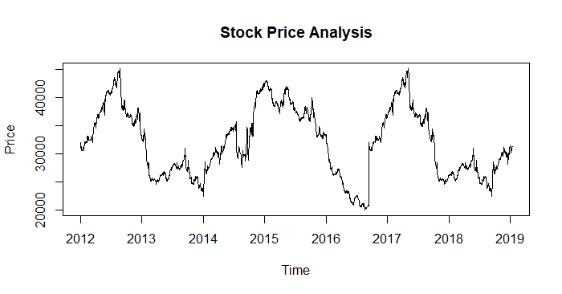

the above chart shows a high level of fluctuations in the stock market. No specific pattern is observed, its looks more like a random walk.

**AUTO.ARIMA prediction:**

Below shows optimum arima (2,1,0) projection for the actual event window.

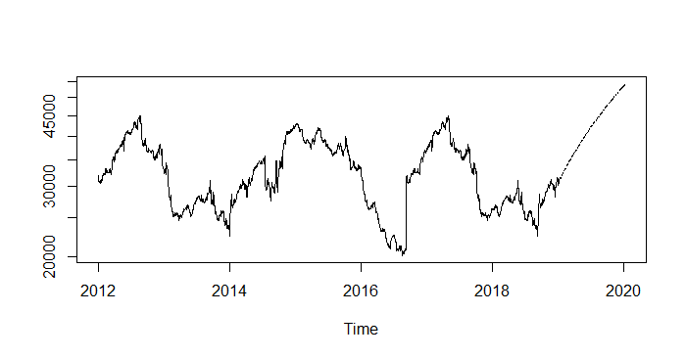

The optimum arima projection actually looks very vague compared to the general trend. Hence, we examined the non-seasonal arima forecast:

Below shows analysis and projection of a non-seasonal ARIMA of order (0,1,0)

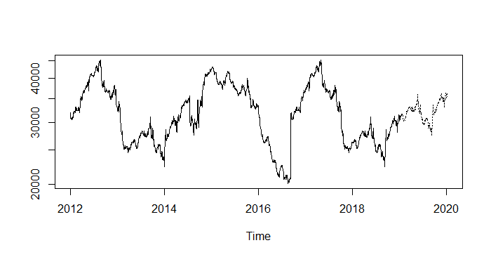

This presented a fair forecast.

Projections versus Actual for the event window:

Optimal ARIMA (2,1,0)

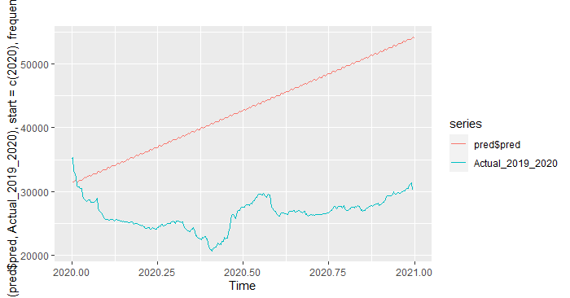

Non-seasonal ARIMA prediction order (0,1,0)

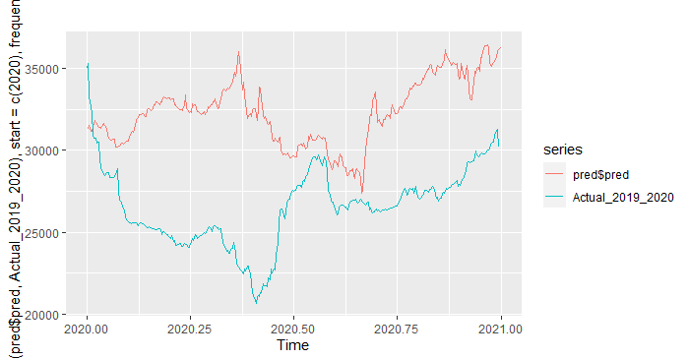

Model Performance Validation.

To validate the performance of our model, we randomly choice a 60point data size and fit our model to predict one step ahead and the result was quite amazing as shown in the plot below. The MAPE was 0.8

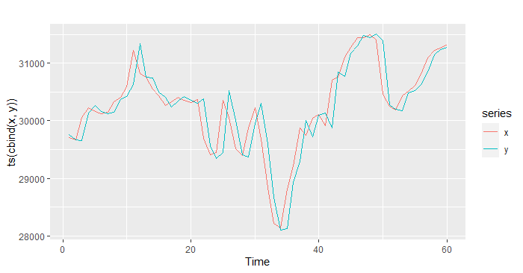

It is also interesting to note that, the stock market of Nigeria, as one of the countries impacted by the outbreak of COVID-19, was severely affected but, the stock market shows a high degree of resilience considering the rebounding performance following its initial plunge. Our empirical results indicate that the outbreak of COVID-19 had a negative but limited impact on stock markets.

Andersen ([2020](https://www.tandfonline.com/doi/full/10.1080/20954816.2020.1757570?scroll=top&needAccess=true&)) also notes that in the research papers of formally modelling pandemic scenarios, many find a large short-run economic impact, but none of them finds a significant long-run impact, even in a very severe scenario.

There may be several factors that make a potential pandemic-generated economic slowdown different from usual recessions. First, recent recessions have been accompanied by large-scale reallocation of labor and other resources across sectors. By contrast, workers unemployed or put on furlough because of coronavirus are likely to resume their former positions. In other words, the former pattern of economic activity can be resumed, whereas usual recessions and their aftermath entail a reconfiguration of economic activity. Second, a general recession is often prolonged by a lack of confidence on the part of investors, firms and consumers. It seems logical, however, that these groups would regain their confidence in the markets once the pandemic recedes.

**Conclusion:**

This paper studies the direct and spill-over effects of COVID-19 on Nigerian stock markets.

Despite the facts that COVID-19 is fiercely hurting the world with its outbreak not reaching a turning point and that the foreign timeline is still extending, the following conclusions can be drawn:

1. Our analysis suggests that COVID-19 has a negative but short-term impact on the stock market.
2. The impact of COVID-19 on stock markets has bidirectional spill-over effects from China to other countries of the world and Nigeria is not an exception.

These findings contribute to the research in economic impacts of the pandemic by providing empirical evidence that COVID-19 has bidirectional spill-over effects on the Nigeria economy. Admittedly, though, since there is no a pandemic mitigation period in Nigeria and the other countries yet while this paper is being written, this study merely provides a reference for the trend of capital markets when the COVID-19 pandemic subsides worldwide.

**Reference:**

1. Andersen, Karen. 2020. “Morningstar’s View: The Impact of Coronavirus on the Economy.” *Stock Strategist Industry Reports*. <https://www.morningstar.com/articles/971254/morningstars-view-the-impact-of-coronavirus-on-the-economy> [[Google Scholar]](http://scholar.google.com/scholar?hl=en&q=Andersen%2C+Karen.+2020.+%E2%80%9CMorningstar%E2%80%99s+View%3A+The+Impact+of+Coronavirus+on+the+Economy.%E2%80%9D+Stock+Strategist+Industry+Reports.+https%3A%2F%2Fwww.morningstar.com%2Farticles%2F971254%2Fmorningstars-view-the-impact-of-coronavirus-on-the-economy)
2. Burch, Timothy R., Douglas R. Emery, and Michael R. Fuerst. 2016. “Who Moves Markets in a Sudden Marketwide Crisis? Evidence from 9/11.” *Journal of Financial and Quantitative Analysis* 51 (2): 463–487. [[Crossref]](https://www.tandfonline.com/servlet/linkout?suffix=CIT0002&dbid=16&doi=10.1080%2F20954816.2020.1757570&key=10.1017%2FS0022109016000211), [[Web of Science ®]](https://www.tandfonline.com/servlet/linkout?suffix=CIT0002&dbid=128&doi=10.1080%2F20954816.2020.1757570&key=000378927300005), [[Google Scholar]](http://scholar.google.com/scholar_lookup?hl=en&volume=51&publication_year=2016&pages=463-487&issue=2&author=Timothy+R.+Burch&author=Douglas+R.+Emery&author=Michael+R.+Fuerst&title=Who+Moves+Markets+in+a+Sudden+Marketwide+Crisis%3F+Evidence+from+9%2F11)
3. Carter, David A., and Betty J. Simkins. 2004. “The Market’s Reaction to Unexpected, Catastrophic Events: The Case of Airline Stock Returns and the September 11th Attacks.” *The Quarterly Review of Economics and Finance* 44 (4): 539–558. [[Crossref]](https://www.tandfonline.com/servlet/linkout?suffix=CIT0003&dbid=16&doi=10.1080%2F20954816.2020.1757570&key=10.1016%2Fj.qref.2003.10.001), [[Google Scholar]](http://scholar.google.com/scholar_lookup?hl=en&volume=44&publication_year=2004&pages=539-558&issue=4&author=David+A.+Carter&author=Betty+J.+Simkins&title=The+Market%E2%80%99s+Reaction+to+Unexpected%2C+Catastrophic+Events%3A+The+Case+of+Airline+Stock+Returns+and+the+September+11th+Attacks)
4. Chen, Ming-Hsiang, Soo Cheong Shawn Jang, and Woo Gon Kim. 2007. “The Impact of the SARS Outbreak on Taiwanese Hotel Stock Performance: An Event-study Approach.” *International Journal of Hospitality Management* 26 (1): 200–212. [[Crossref]](https://www.tandfonline.com/servlet/linkout?suffix=CIT0004&dbid=16&doi=10.1080%2F20954816.2020.1757570&key=10.1016%2Fj.ijhm.2005.11.004), [[Google Scholar]](http://scholar.google.com/scholar_lookup?hl=en&volume=26&publication_year=2007&pages=200-212&issue=1&author=Ming-Hsiang+Chen&author=Soo+Cheong+Shawn+Jang&author=Woo+Gon+Kim&title=The+Impact+of+the+SARS+Outbreak+on+Taiwanese+Hotel+Stock+Performance%3A+An+Event-study+Approach)
5. Duan, Hongbo, Shouyang Wang, and Cuihong Yang. 2020. “Coronavirus: Limit Short-term Economic Damage.” *Nature* 578 (7796): 515. [[Crossref]](https://www.tandfonline.com/servlet/linkout?suffix=CIT0006&dbid=16&doi=10.1080%2F20954816.2020.1757570&key=10.1038%2Fd41586-020-00522-6), [[Web of Science ®]](https://www.tandfonline.com/servlet/linkout?suffix=CIT0006&dbid=128&doi=10.1080%2F20954816.2020.1757570&key=000516571100008), [[Google Scholar]](http://scholar.google.com/scholar_lookup?hl=en&volume=578&publication_year=2020&pages=515&issue=7796&author=Hongbo+Duan&author=Shouyang+Wang&author=Cuihong+Yang&title=Coronavirus%3A+Limit+Short-term+Economic+Damage)

Appendix:

Keywords: [COVID-19](https://www.tandfonline.com/keyword/COVID-19), [coronavirus disease](https://www.tandfonline.com/keyword/Coronavirus+Disease), [stock markets](https://www.tandfonline.com/keyword/Stock+Markets), spill-over-effects